Use-Case Realization Report (Analysis)
Display MCQ Info

Issue 1.0
Revision History
Date | Issue | Description | Author
01/Aug/09 | 1.0 | First Issue | Thomas Yap

Table of Contents
1. Brief Description 4
2. Flow of Events 4
2.1 Standard Flow 4
2.1.1 Display MCQ Info 4
2.2 Exception 4
3. Interaction Diagrams 5
3.1 Collaboration Diagram for Display MCQ Info 5
4. Participating Objects 5
5. Class Diagrams 6
5.1 Class Diagram for Display MCQ Info 6
6. Derived Requirements 6

Use-Case Realization Report
Display MCQ Info

Brief Description
This use case enables the controller to update multiples choice question profile with its properties and parameters. It involves displaying the menu and form and search by searchstrings to display the details.

Flow of Events
The standard flow of events for this use case and any exceptions are described in the following subsections. The events are described in terms of Actors and Analysis Objects.

Standard Flow
This use case covers the MCQ Maintenance - Display MCQ Info. The standard flow of these events are described below.

Display MCQ Info
The running of the application is shown in section 3.1. The flow of event is as follow:

- When the application start, the first operation to be performed is the startup operation of the main controller. This operation will create all the control objects and the entity objects necessary for operation Update MCQ:
  - The control object created is: MCQ Controller
  - The entity objects create are: MCQ Table and Transaction Record

- The main controller will start the main function menu:
  - To start Display MCQ Info, operation FormDisplayMCQ is activated by MCQ Controller to display a MCQ form.
  - Portal Admin then input searchstrings for searching the record. The searchstrings can be the MCQ ID and MCQ Name.
  - Operation validate will validate the format of the entries.
  - Then MCQ Controller will check for additional criteria if any.
  - If no record found, MCQ Controller will send a error message to FormDisplayMCQ Interface.
  - After the record is found and display on FormDisplayMCQ.
  - A transaction log will be created by operation createActivity and store in entity TransactionRecord.

- Step 2 will be repeated until all searches are completed. Then controller will terminate the application by issuing operation close.

Exception
None.

Interaction Diagrams

Collaboration Diagram for Display MCQ Info
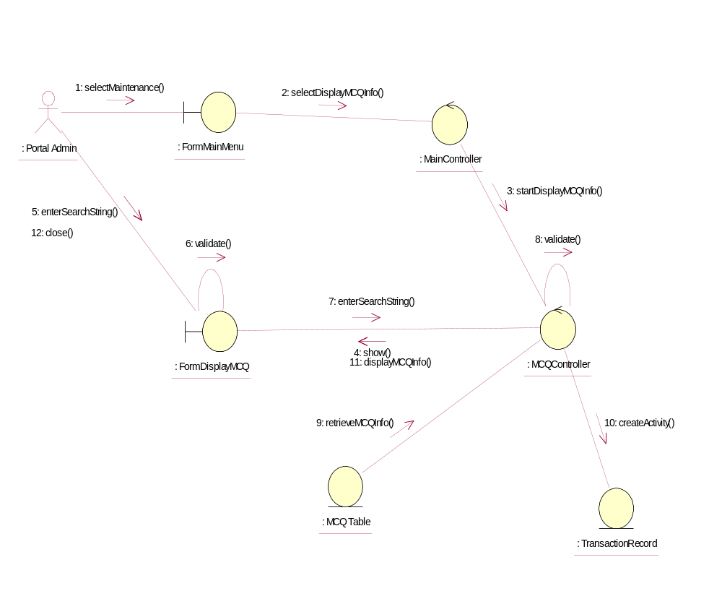

Participating Objects
: FormDisplayMCQ
This object is the interface for displaying MCQ details search activities.

: FormMainMenu
This is the main menu at the beginning of the application from where it can access the MCQ Maintenance - Display MCQ Info operation.

: MainController
This is the main controller that control the whole system.

: MCQ Table
This table stores all the properties and parameters of exam or exercise questions.

: MCQController
This is the controller for MCQ Maintenance. It creates and activates FormDisplayMCQ interface and MCQ Table.

: Portal Admin
This is the only actor that authorized to perform operation MCQ Maintenance - Display MCQ Info.

: TransactionRecord
This is the entity object that created for transaction log and audit trail.

Class Diagrams

Class Diagram for Display MCQ Info
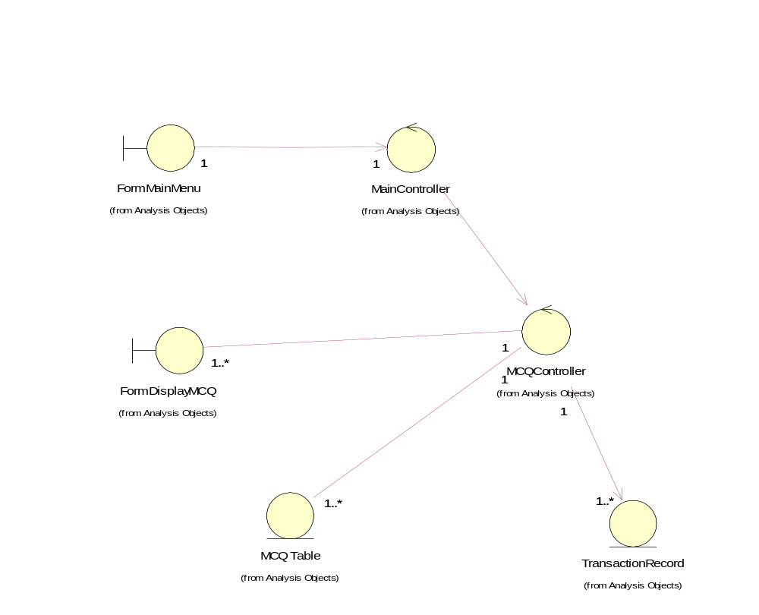

Derived Requirements
The FormMainMenu and FormDisplayMCQ Interface should have the format specified in User Requirements Specification for Content Management Portal.

